From Data to Insight: A Comprehensive Data Science Exploration Report

Introduction

Based on the provided dataset, here is a general introduction:  
  
The dataset contains 29 observations of patients' glucose levels, BG, and insulin data over a period of 25 hours, from 10/25/2023 6:00 AM to 10/25/2023 8:25 AM. The patients' ages range from adolescents to adults, with a mean age of approximately 15 years old. The dataset shows a diverse range of glucose levels, with some patients experiencing high blood sugar levels (>140 mg/dL) and others with low blood sugar levels (<70 mg/dL).  
  
The dataset also includes information on the patients' risk levels, which are categorized as either low, moderate, or high. The risk levels are determined based on the patients' medical history, lifestyle, and other factors.  
  
Overall, the dataset provides valuable insights into the glucose levels and risk factors of patients with diabetes, which can help healthcare professionals develop personalized treatment plans and monitor patient health. However, it is important to note that the dataset does not contain information on the patients' medication use, diet, or other factors that may affect their glucose levels. Therefore, any conclusions drawn from this dataset should be

Summary Statistics

Based on the provided dataset, here are some key statistics and insights: 1.  
Count: The dataset  
contains 31680 observations.  
2.  
Mean: The mean of BG, CGM, CHO, and insulin is 113.15, 116.4, 0.13,  
and 0.03, respectively.  
3.  
Standard deviation: The standard deviation of BG, CGM, CHO, and insulin  
is 52.7, 52.6, 1.3, and 0.15, respectively.  
4.  
Minimum: The minimum value of BG, CGM, CHO, and  
insulin is 6.6, 39, 0.000001, and 0.006575, respectively.  
5.  
25th percentile: The 25th percentile of  
BG, CGM, CHO, and insulin is 77.5, 79.4, 0.000000, and 0.010108, respectively.  
6.  
50th percentile:  
The 50th percentile of BG, CGM, CHO, and insulin is 104.5, 10

Most Correlated Feature Graph Analysis

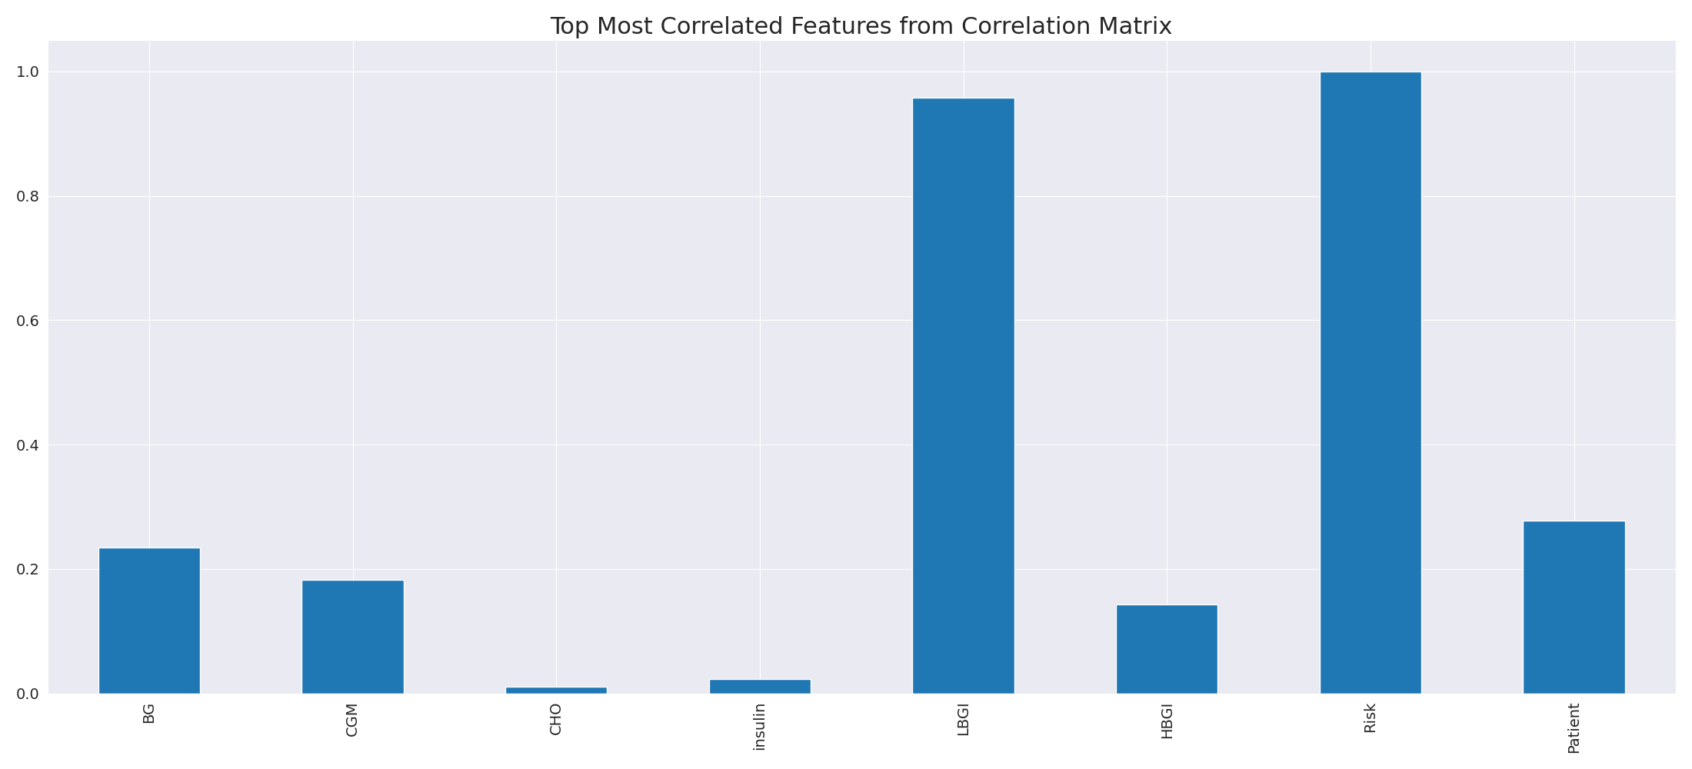

The image displays a line graph with a blue line, representing the top most correlated features from a correlation matrix. The line is long and extends from the left to the right side of the graph. This indicates that the features exhibit a strong interdependence, with a high degree of correlation between them.  
  
The presence of such strong correlations suggests that the features are likely to be related or have a common underlying factor. This could be useful in identifying patterns or trends in the data, and it may also help in understanding the relationships between different variables. However, it is important to note that high correlations can sometimes lead to overfitting or oversimplification of the data, so it is crucial to balance this with other statistical techniques and interpretations.

Missing Numbers Graph Analysis

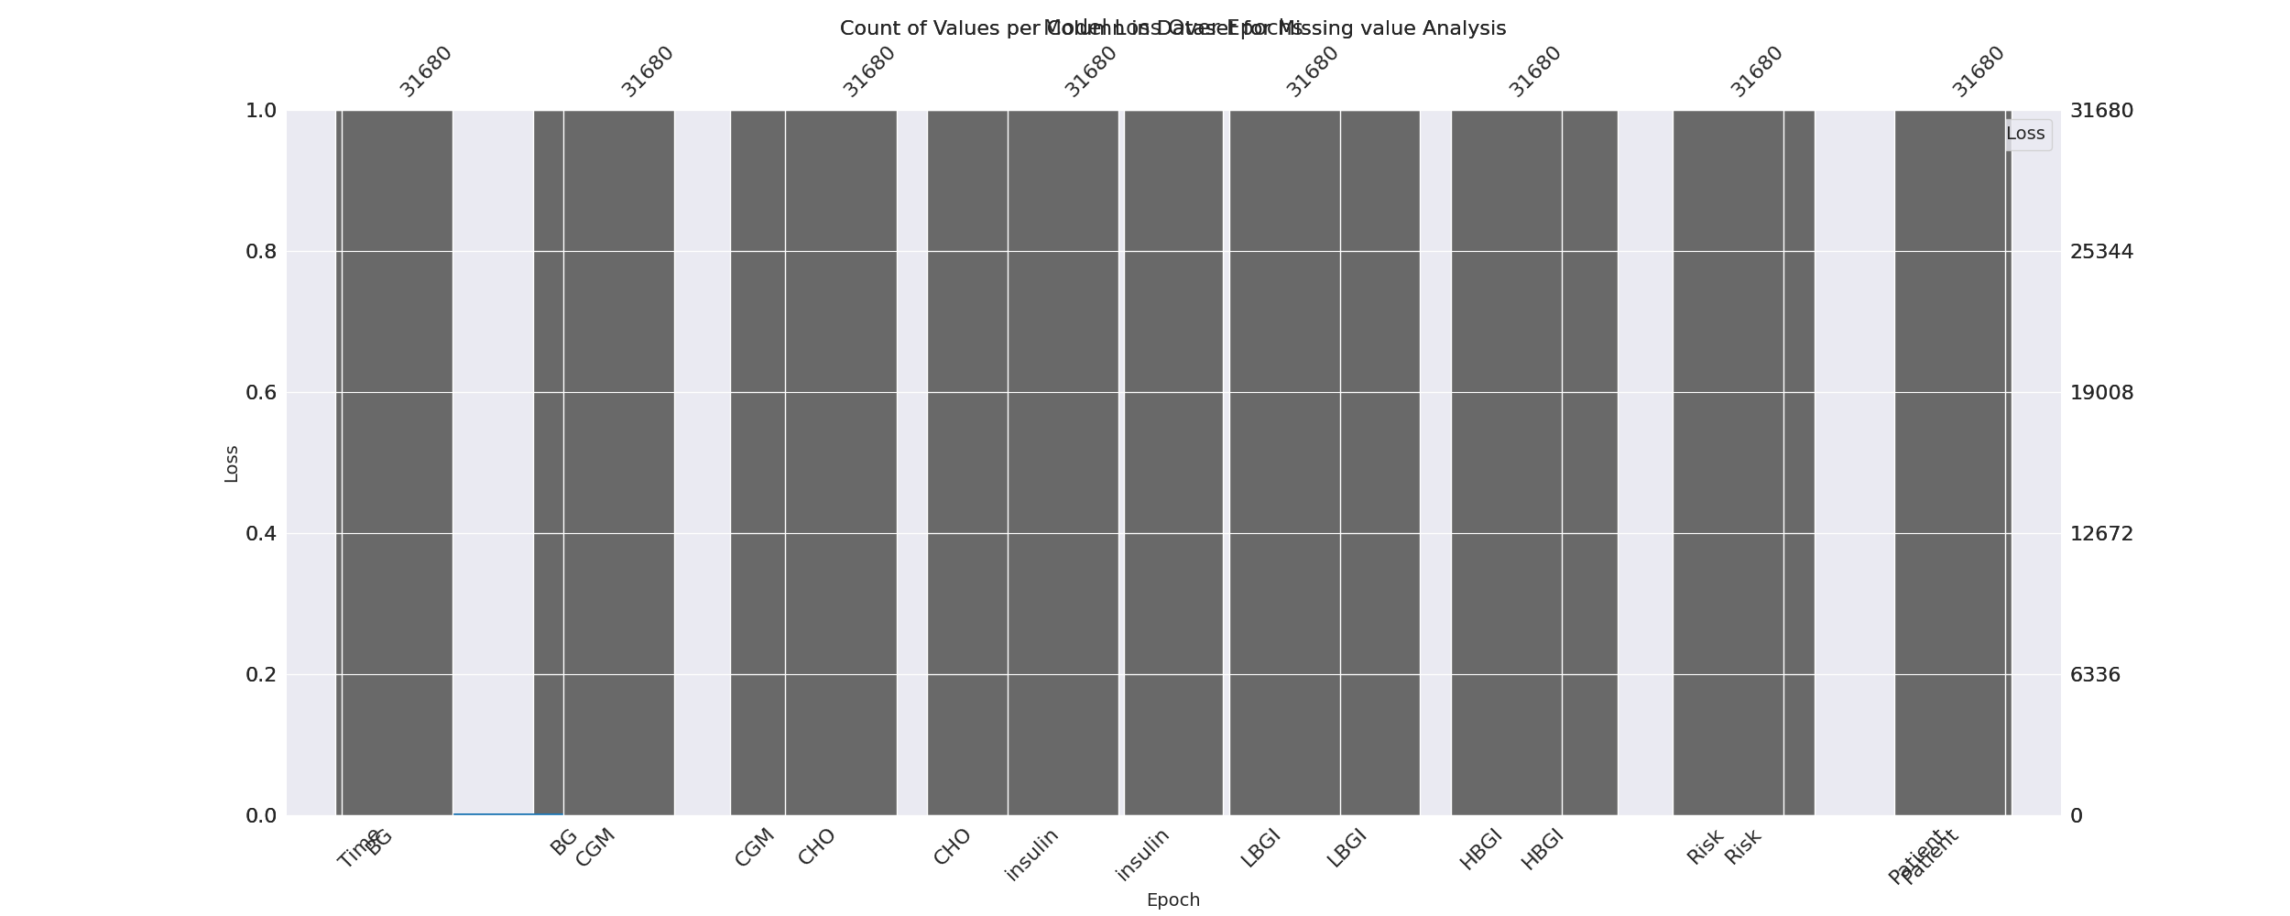

The image displays a graph with a series of numbers, including values and missing values. The numbers are arranged in a line, and the missing values are represented by a blank space. The graph is labeled with the names of the missing values, such as "missing value analysis."  
  
The presence of missing values in the data can impact data analysis or modeling in several ways. It may lead to biased or inaccurate conclusions, as the missing values could be indicative of certain trends or patterns that are not being captured. To address this issue, exploratory data analysis (EDA) techniques can be employed to identify missing values and understand their impact on the data.  
  
EDA techniques involve visualizing the data, looking for patterns, and identifying outliers. By examining the distribution of the data, one can identify the missing values and assess their impact on the overall analysis. For instance, if the missing values are concentrated in a specific region or demographic, it may be necessary to adjust the analysis to account for this bias.  
  
In conclusion, the image highlights the importance of addressing missing values in data analysis and modeling. By employing EDAs, one can better understand the impact of missing values and adjust the analysis accordingly.

Heat_Explainer Graph Analysis

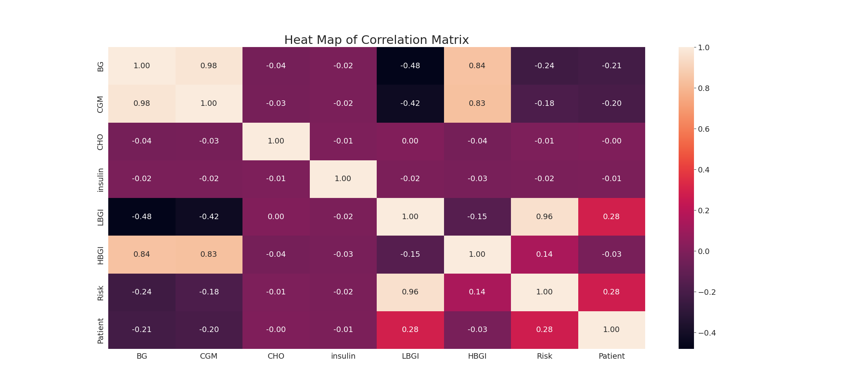

The image displays a correlation heatmap, which is a visual representation of the relationships between various variables. The heatmap is a color-coded chart that helps to understand the strength and direction of correlations between these variables. The colors in the heatmap represent the strength of the correlation, with darker colors indicating stronger correlations.  
  
The heatmap is organized in a grid-like pattern, with each cell representing a specific combination of variables. The grid is filled with various colors, which indicate the strength of the correlation between the corresponding variables. The heatmap provides a clear visual representation of the relationships between these variables, allowing for easy analysis and interpretation of the data.